***CSC 229 Programming 50 points***

***Project 01***

**Develop a complete Java program to prompt the user for personal information and the terms of a mortgage loan using input dialogues as follows:**

* **First Name**
* **Last name**
* **Address**
* **City**
* **State**
* **Zip code**
* **Principal (P)**
* **annual interest rate (r)**
* **Number of years (n)**

**use the following formula to calculate the monthly payment:**

Monthly Payment = P(k(1+k)m) /(1+k)m-1)

**Where:**

**k = r/12/100 (monthly interest rate)**

**m = n*12 (number of payments)**

**Report all information and monthly payment using an output dialogue.**

**Name your Java file and Class Project01.**

**Document your program properly.**

**First Sample Run**

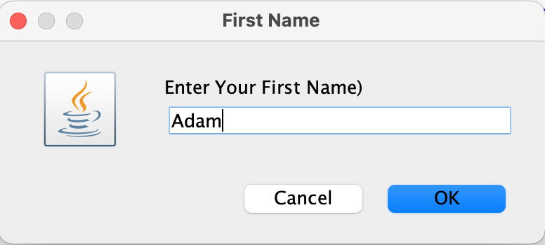

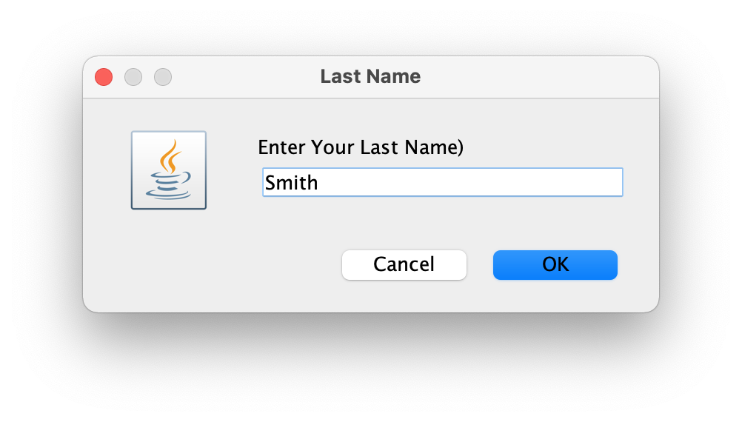

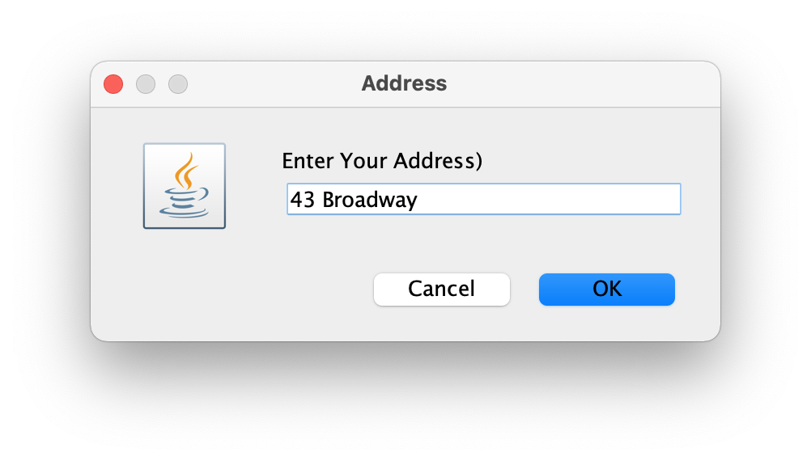

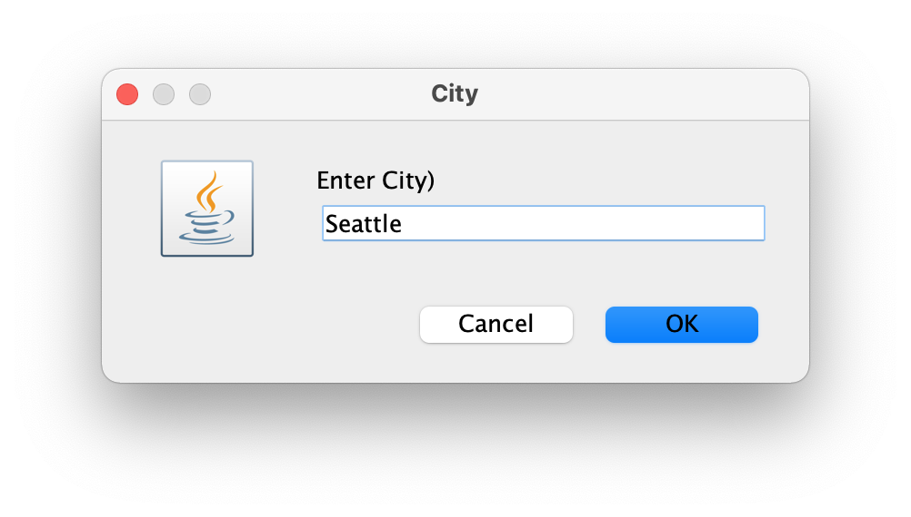

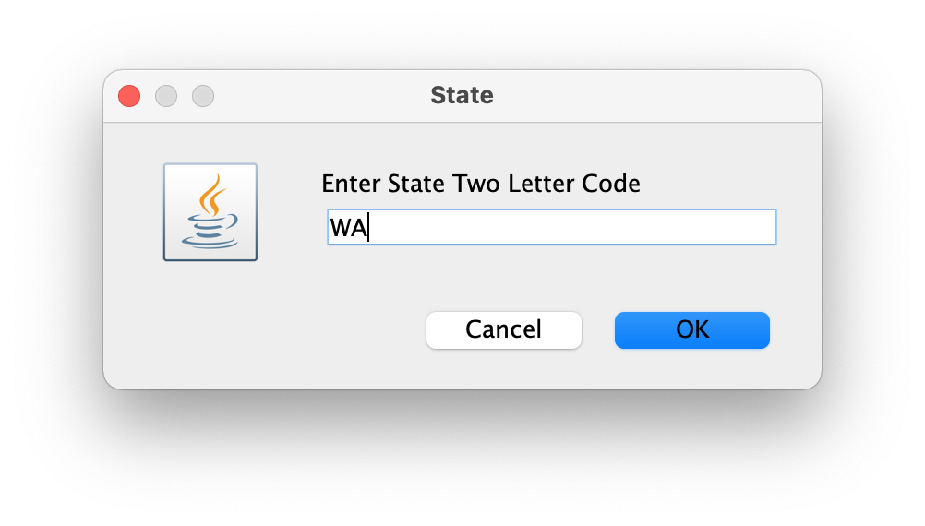

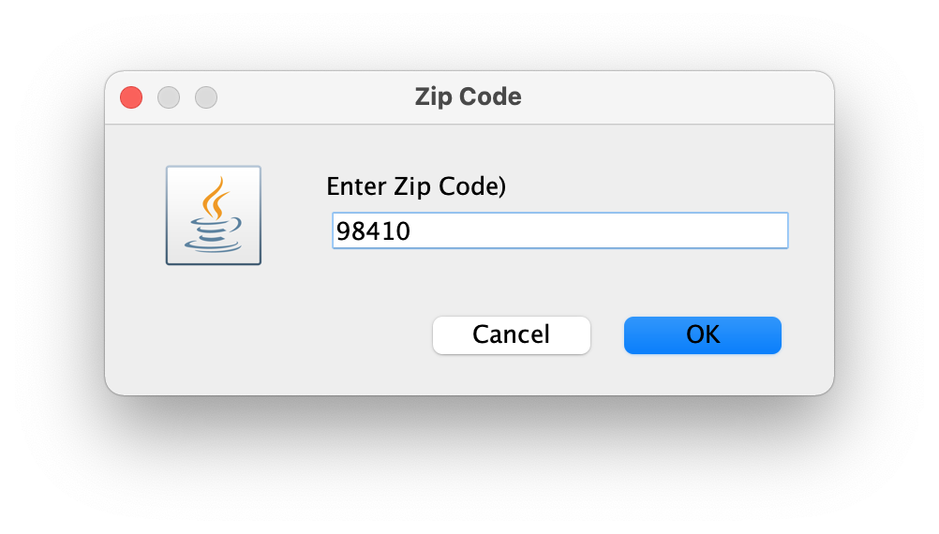

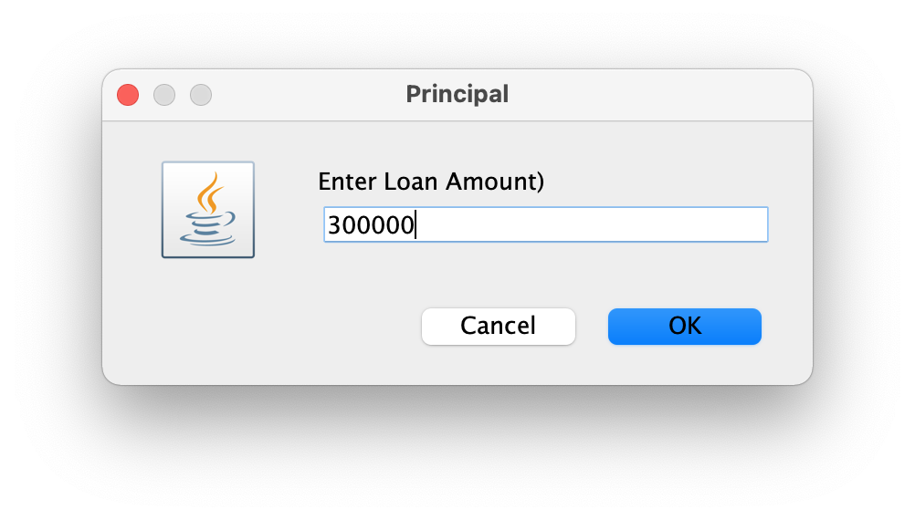

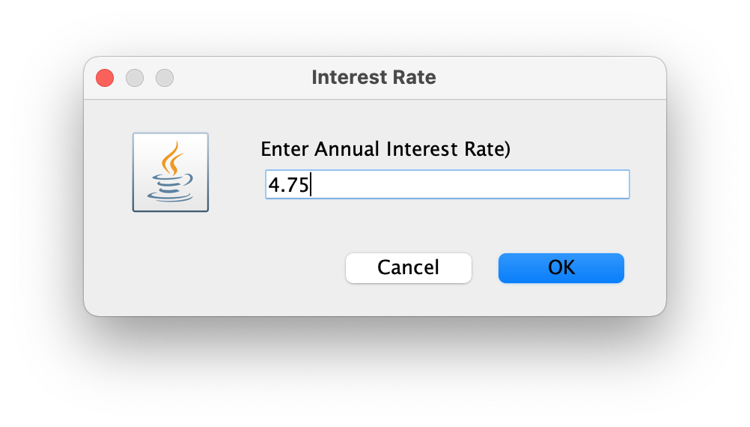

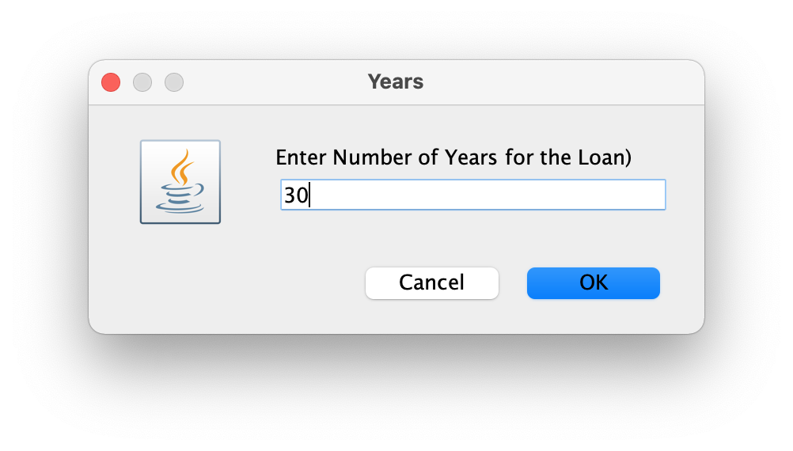

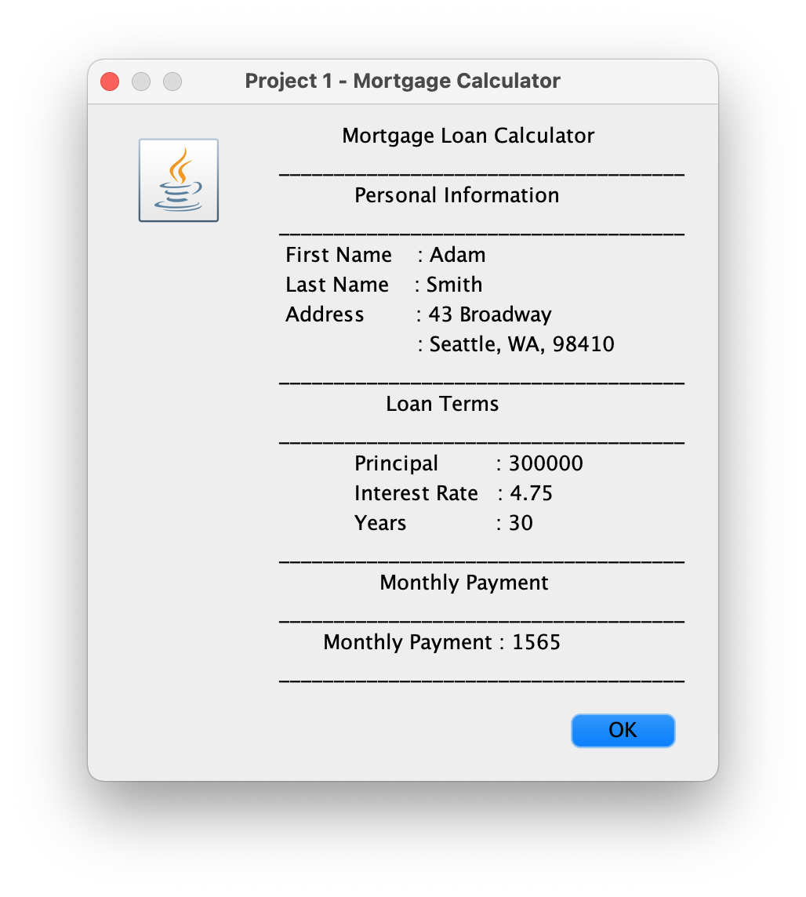

**Second Sample Run**

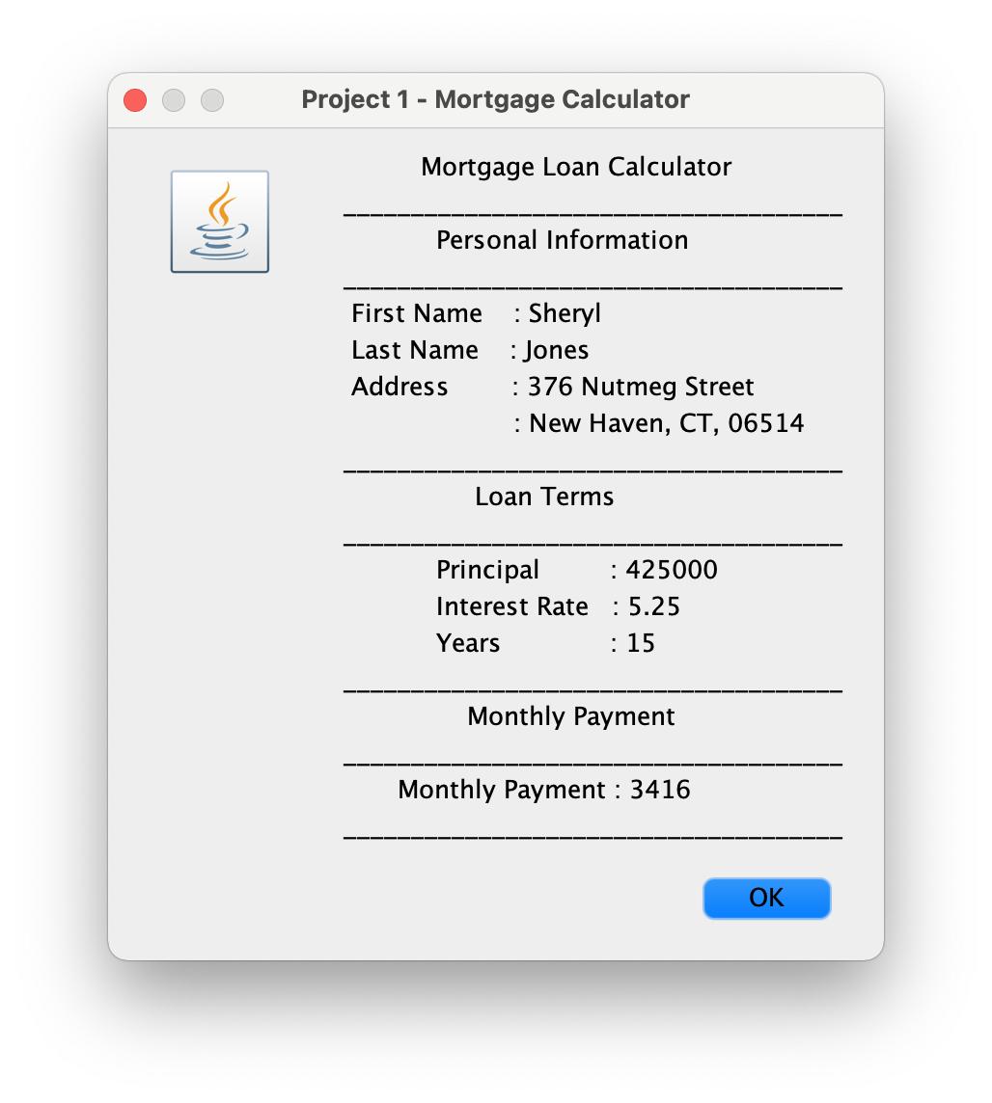

**Submit:**

* **Java (.java file) and runnable jar file zipped in a single file named as your last name through Black Board.**
* **Submit Java file(s) (JUST JAVA FILE(S) NOT JAR FILE) through** [**seyedt1@southernct.edu**](mailto:seyedt1@southernct.edu) **as an attachment to an email with subject line that reads as “ CSC 229 - Project 1 – your last name”. This submission is to avoid possible problems with BB and DOES NOT substitute BB submission**

**Links to how to make dialogs in Java:**

[**https://docs.oracle.com/javase/tutorial/uiswing/components/dialog.html#features**](https://docs.oracle.com/javase/tutorial/uiswing/components/dialog.html#features)

[**https://docs.oracle.com/javase/7/docs/api/javax/swing/JOptionPane.html**](https://docs.oracle.com/javase/7/docs/api/javax/swing/JOptionPane.html)

**input dialog box example:**

firstName = JOptionPane.*showInputDialog*(**null**,

"Enter Your First Name)",

"First Name", JOptionPane.***QUESTION_MESSAGE***);

input = JOptionPane.*showInputDialog*(**null**,

"Enter Loan Amount)",

"Principal",

JOptionPane.***QUESTION_MESSAGE***);

principal = Double.*parseDouble*(input);

**Output dialog box example**

JOptionPane.*showMessageDialog*(**null**,

" Mortgage Loan Calculator"+"\n"+"\n"+

" _____________________________________" +"\n"+

" Personal Information "

" _____________________________________" +"\n"+

" First Name : " + firstName +"\n"

,"Project 1 - Mortgage Calculator",

JOptionPane.***INFORMATION_MESSAGE***);